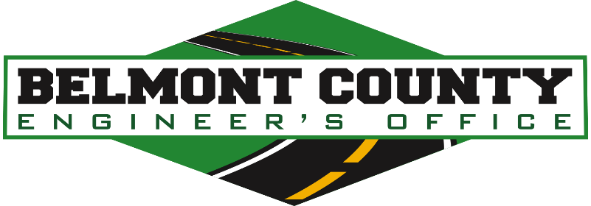

INSTRUCTIONS FOR COMPLETION OF THE
ROADWAY USE AND MAINTENANCE AGREEMENT

- Complete all yellow highlighted portions of the RUMA with accurate information.

- If there is additional language added to the agreement or modified in any way, please allow time for our attorney to review the new language.

- Highlight or make bold any content changes.

- Include a map of the roads that will be under consideration.

- Return a PDF and the revised word document to the Engineer’s Office.

- If a bond is required, then we must have the original raised seal document to enter into the agreement.

- If the bond is replaced, modified, or cancelled documentation should be sent to the following address:

Belmont County Engineer’s Office
Attn: Office Manager
101 W. Main Street
St. Clairsville, OH 43950
(740) 699-2160

